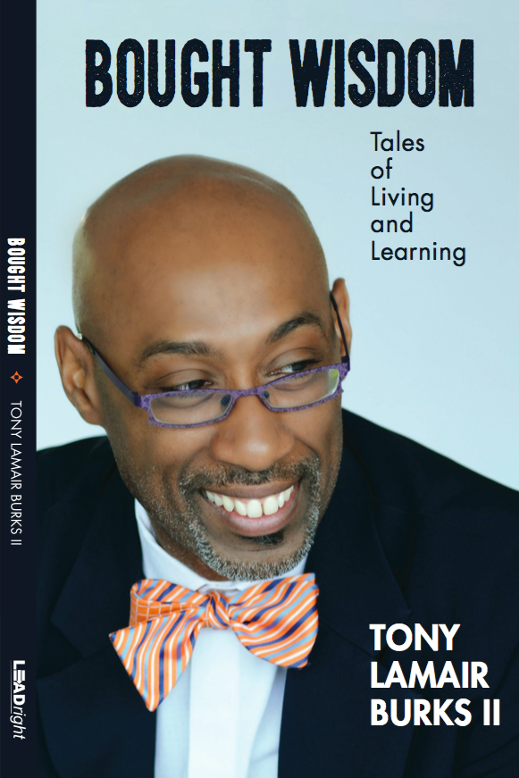 | BOUGHT WISDOM  Tales of Living and Learning  Tony Lamair Burks II  Interactive Memoir | Nonfiction  172 pages | paperback  Publisher: LEADright  Publication Date: April 14, 2017  ISBN-13: 978-0692871188  ISBN-10: 0692871187  CONTACT  lead@LEADrightToday.com  619-796-6463  ORDER  www.leadrighttoday.com/boughtwisdom

THE BOOK
When Dr. Tony Lamair Burks II packed the last of his personal belongings that crisp afternoon, he looked around his barren school office once more: What had he learned? How would he be different? What was his Bought Wisdom?

“Bought Wisdom” is part interactive memoir, part leadership story, and part reflective journal. Discover how one person’s journey can help you:

· Reflect on your living and learning
· Recover from your setbacks
· Reframe your thinking about experiences
· Tell your story to encourage yourself and inspire others

Bought Wisdom is the kind of wisdom you get from experiencing life and all it tosses your way. We’d do well to learn from the Bought Wisdom of others.

THE AUTHOR
Dr. Tony Lamair Burks II is Chief Learning Officer of LEADright, where he coaches and trains leaders for excellence. He was the founding principal-director of The Early College at Guilford, North Carolina’s first early college high school and one of the first such schools of its type in the world. He is among five educators featured in Walking the Equity Talk: A Guide for Culturally Courageous Leadership in School Communities by John Robert Browne II; and he has been recognized by NU-tribe Magazine as one of "Six HBCU Grads You Should Know".

THE FAQS
QUESTION: When did you write Bought Wisdom: Tales of Living and Learning?
RESPONSE: I started writing Bought Wisdom: Tales of Living and Learning in 2011. However, I did write two of the chapters (i.e., On Becoming and Preachin’ John) in the mid-to-late 1990s as projects for special courses. Principal Mitzi Yates Lizàrraga invited me to speak to her graduating high school seniors one day in 2011. Part of my speech that day was the seed that grew into Bought Wisdom: Tales of Living and Learning.

QUESTION: Where did you get the idea for the book’s title?
RESPONSE: It was Dr. Lora Hodges who first schooled me on “Bought Sense.” It’s how her mother described the kind of wisdom you get from experiencing life and all it tosses your way. Her mother said we’d do well to learn from the Bought Sense of others.

QUESTION: So you’re saying Bought Wisdom is the kind of wisdom for which you pay a price?
RESPONSE: Absolutely! It’s as simple as knowing whose Pound Cake you shouldn’t eat at the church cookout. Bought Wisdom is also leaving the house, hearing that still small voice telling you to go back, and doing so only to find a loved one on the floor in need.

QUESTION: Why do you describe Bought Wisdom: Tales of Living and Learning as part interactive memoir, part leadership story, and part reflective journal?
RESPONSE: Bought Wisdom: Tales of Living and Learning is a memoir because it has 15 chapters that are snapshots of moments in my life. It is a leadership story because the chapters weave a story about who I have become as a leader. It’s the reflective journal aspect; however, that makes the book an interactive memoir. I have space to journal at the end of each chapter and I offer a few questions and prompts to “prime the pump” for writing stories.

QUESTION: What other writing projects do you have on the horizon?
RESPONSE: A few more books are on the horizon in the next 24 months. I’m working on a children's book entitled Uncle Pigg, The People’s Tailor. A few colleagues and I intend to co-author a field guide for educational leaders. Perhaps we’ll call it Time to Lead: 21 Practical Time-saving Tools for Today’s Educational Leaders. I plan to co-edit Bought Wisdom, Volume II: Only Flowers Bloom Silently, an anthology of stories. To learn more about the anthology and to submit your stories for consideration, go to www.leadrighttoday.com/SubmitYourStory

QUESTION: What’s the message of Bought Wisdom: Tales of Living and Learning?
RESPONSE: Bought Wisdom is about articulating and unpacking our stories to propel us into the lives we desire. Though I share stories from my life, Bought Wisdom is not about the past or what has been. Badger—a character in one of my favorite books, Crow and Weasel by Barry Lopez—talks about the importance of storytelling. She says,

The stories people tell have a way of taking care of them. If stories come to you, care for them. And learn to give them away where they are needed. Sometimes a person needs a story more than food to stay alive. That is why we put these stories into each other’s memory.

My hope is that my “Bought Wisdom” will inspire you to write your own stories so you may “give them away [when and] where they are needed.” Ultimately, Bought Wisdom is universal.

THE PRAISE
BOUGHT WISDOM is an amazing resource for educators and administrators and students from any discipline, and for those who value teaching and learning. The stories, lessons, and anecdotes that Dr. Burks shares in BOUGHT WISDOM will forever resonate within you.
SANDI MCCREE, MFA, actress (Delonda Brice in HBO’s “The Wire” and Bobby Brown’s mother, Carole, in BET’s “The New Edition Story”), youth advocate, and president, Thought Provoking Arts Company

I have found him to be an authentic care-taker, passionate advocate, and keenly intellectual educator who balances both theory and practice in such a way as to provide an achievable but forward-thinking and provocative vision.
DARIAN C. JONES, PH.D., K-12 education expert and founder and chief academic officer, Sankore’ Prep

You walk in his shoes, feeling the awakening pinch of failure and the joy of triumph.
KADHIR V. RAJAGOPAL, ED.D., author, Create Success! Unlocking the Potential of Urban Students

[BOUGHT WISDOM is] an inspirational read for all ages containing valuable spiritual nuggets embedded within each story. [It is a] wonderful example of living life with strength, courage, and a sense of adventure!
REV. SHARON THOMPSON, co-spiritual director, Living Truth 365

[Dr. Burks] is insightful and painfully honest about what it takes to get [organizations] and professionals to perform at high levels as well as the tremendous amount of sacrifice involved.
STANTON E. LAWRENCE, SR., ED.D., assistant superintendent for administration, San Antonio Independent School District

[Dr. Burks] is one of the young geniuses engaged in the noble work of transforming K-12 Education and is a leader who knows the value of “learning without limits.”.
RONNIE PRICE, vice president of human resources, Chattahoochee Technical College

Tony’s writing is engaging, delightful, and thought- provoking.
RUBY K. PAYNE, PH.D., author, A Framework for Understanding Poverty and Learning Structures

BOUGHT WISDOM warms the heart, tickles the funny-bone and kindly asks its readers to playfully ponder and then participate.
FRED-RICK L. ROUNDTREE, MFA, special assistant to the provost, Winston-Salem State University

His work exemplifies culturally courageous leadership in every respect, causing me to feature him in a chapter of my book … .He really walks his talk.
JOHN ROBERT BROWNE II, ED.D., author, Walking the Equity Talk: A Guide for Culturally Courageous Leadership in School Communities and CEO, Third Millennium Enterprises

BOUGHT WISDOM creates conditions for leaders to become their own best teachers.
LARRY D. COBLE, ED.D., co-author, The Hidden Leader and Staying on Track

Tony Lamair Burks II is a passionate educator and a strong advocate for students. He is an impressive role model for lifelong learning and self- improvement with high achievement aspirations.
LIBIA GIL, PH.D., assistant deputy secretary and director, Office for English Language Acquisition, United States Department of Education

❧❧

Bought Wisdom: Tales of Living and Learning is available in paperback at www.leadrighttoday.com/boughtwisdom

For bulk orders, contact the publisher at lead@LEADrightToday.com

