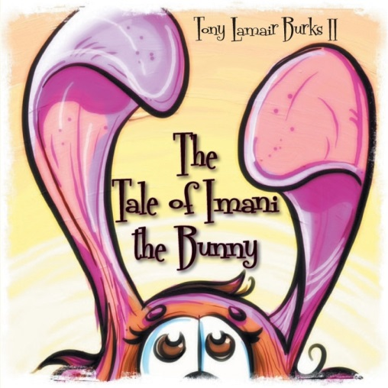 | The Tale of Imani the Bunny  Tony Lamair Burks II  Atlanta, Georgia  24 pages  Children | Fiction  Publisher: Booklocker  Publication Date: January 1, 2014  ISBN-10: 162646460X  ISBN-13: 978-1626464605

QUESTION: When did you write The Tale of Imani the Bunny?
RESPONSE: I wrote The Tale of Imani the Bunny in 1997 while I was a high school teacher at the University School of Nashville, a K-12 independent school in Tennessee.

QUESTION: What was the inspiration for The Tale of Imani the Bunny?
RESPONSE: I was pursuing a master’s degree at Trevecca Nazarene University. My professor, Dr. Charles Beaman, gave us final assignment to communicate our understanding of W. Edwards Deming's idea of continuous improvement. Some classmates wrote essays, others created art, and I wrote a children's book. I embedded Deming's "Plan-Do-Check-Act" cycle in The Tale of Imani the Bunny and dedicated the book to my god-daughter, Alexa Imani.

QUESTION: Why did it take 16 years to get The Tale of Imani the Bunny published?
RESPONSE: Fear and perfectionism. I worried that The Tale of Imani the Bunny wasn’t good enough so I read it to lower school children at University School of Nashville again and again to make it perfect. Just before celebrating my 28th birthday, I was became the principal of Crockett Elementary School. I read The Tale of Imani the Bunny during each of my weekly all-school assemblies. I submitted the book to a couple of contests and it was rejected every time. Eventually, I incorporated The Tale of Imani the Bunny into my StoryWeaving concerts with students around the world. I asked listeners to use the power of imagination to see Imani as I read The Tale of Imani the Bunny to them.

QUESTION: What was the process of bringing The Tale of Imani the Bunny to life?
RESPONSE: It was highly collaborative and it required me to remember EVERYTHING I learned in preschool with Mrs. Lottie C. Kelly and in second grade with Mrs. Joyce Whiting. Initially, had two things taking place at once: a thumbtack search to find an illustrator and a Kickstarter campaign to raise funds to pay the illustrator and the designer. I posted this request at thumbtack.com:

Illustrating a children's book that I wrote for my god daughter 15 years ago. I'd like to get it published before December 2012. I have the concept for the artwork in mind.

Luis Peres was among six illustrators who responded. He sent me samples of his work and offered to sketch an image of Imani in response to this email message I wrote:

Good afternoon! It's called the Tale of Imani the Bunny. It will be 14-22 pages long depending on the placement of words and illustrations. My vision is this: the illustrations focus in tightly on things suggested by the story. For example, the passage about Imani hopping along bunny trails would show a tight shot of her feet. Likewise the passage referencing her ears would highlight her bunny ears. The last page would be the "reveal" that would show Imani, my god daughter, as a little girl who imagined herself as the bunny. The image I have in my head for the final page is one wherein the reader would see Imani with a headband with fake bunny ears sticking out.

Over the next months we sent images back and forth through email and thumbtack. The illustrator even created four of Youtube videos (e.g., http://youtu.be/1Xm3EaaW9ec ) so that I could understand his creative process. We launched and successfully completed a Kickstarter crowdfunding campaign. Somewhere along the way I decided to have The Tale of Imani the Bunny published in Spanish and English so I contacted my dear friend and high school Spanish teacher, Jade Dickerson (Jade, an artist in his own right, was initially tapped to illustrate the book). After this step, we engaged a wonderful designer who assisted me in choosing a font and determining the placement of each word in the book. Bringing The Tale of Imani the Bunny to life was a multicultural, multinational effort, spanning ZIP codes and time zones. I live in Atlanta, Georgia; the illustrator lives in Portimão, Portugal; the translator calls Greensboro, North Carolina home; I received technical assistance from a Spanish translator who lives in Zapopan, Jalisco, Mexico; the graphic designer works from Red Deer, Alberta, Canada; the publisher is based in Bradenton, Florida; and each copy of The Tale of Imani the Bunny is printed in La Vergne, Tennessee.

QUESTION: How did the Kickstarter campaign go and how much money were you able to raise?
RESPONSE: The Imani Kickstarter campaign was my first experience with crowdfunding. It was an amazing experience thanks to my circle of family and friends. I remain humbled and honored by the outpouring of support for The Tale of Imani the Bunny. It took 24 people less than 24 hours to reach 58% of my Kickstarter funding goal of $2,931. In fact, we’d approached 70% of the funding goal with 48 days remaining. The campaign was successfully funded on June 7, 2013, by 59 backers who pledged $3,505.

QUESTION: What other writing projects to you have on the horizon?
RESPONSE: Now that my first book has been published, a few more books are on the horizon in the next 18 to 24 months. I’m working on a children's book entitled Uncle Pigg: The People's Tailor. I’m in the editing phase of a leadership memoir entitled Bought Wisdom: Tales of Living and Learning (an excerpt can be found at www.LeadRightToday.com/boughtwisdom). I’ll be editing a volume of stories from top performing urban schools under the working title Only Flowers Bloom Silently and Other Stories from America's Best Urban Schools. I’m collaborating with a colleague on a book exploring why good people leave relationships and organizations.

QUESTION: Why is The Tale of Imani the Bunny in Spanish and English?
RESPONSE: In my travels outside the United States of America, I have witnessed students of all ages mastering their language and English. It is fascinating to me that what others do as a part of learning (studying multiple languages), we as US citizens belittle, demean, or avoid. We demand that people speak English when they are in the United States and when we are abroad in their countries. So, The Tale of Imani the Bunny is also about exposing our children to the Spanish language, expanding their horizons, and empowering them as communicators.

QUESTION: What is the message of The Tale of Imani the Bunny?
RESPONSE: Imagination and faith are key messages of The Tale of Imani the Bunny—and there are others in the curriculum guide for the book. Imani sees herself as successful. She puts her faith to action. Imani doesn’t give up when she’s unsuccessful. She spends time improving her skills. Imani is reflective. She is persistent. Imani is open and responsive to the support of her parents and her peers. The Tale of Imani the Bunny invites children and adults to explore, learn, grow, and become.

Author: Tony Lamair Burks II is a native of Dothan, Alabama, the peanut capital of the world. He is an alumnus of Morehouse College, Trevecca Nazarene University, and the University of North Carolina at Greensboro. A master whistler and StoryWeaver, The Tale of Imani the Bunny is his first published children’s work.

The Tale of Imani the Bunny is available in paperback and as an ebook at Booklocker.com
Booksellers may order WHOLESALE directly from Booklocker.com

Revised January 15, 2014

