What French diplomat and novelist, Jean Giraudoux, once wrote is at the crux of my approach to school improvement and school transformation: “Only the mediocre are always at their best.”

My guiding questions are: (1) What do we want to provide to the students of Frederick Douglass High School?; (2) How might we provide this?; and (3) How will we know when we have done it well?

In order to improve student achievement, we must expect higher performance, we must assist so that students have access to equitable learning opportunities, and we must tailor support to fit the needs of Frederick Douglass High School. To this end I use an Appreciative Inquiry approach. Appreciative Inquiry asks “what is working well around here?” instead of asking solely “what problems are we having and why are we having them?”

Each teacher is asked to read “Autobiography in Five Short Chapters” and then write a data story in response to these questions:

What is your data story as a teacher? Why did your results turn out the way they did? What stands out? What surprises you? How do the results compare with your intuition or personal experience? What are emerging themes? What are your next steps? How may your instructional coach, instructional data coach, academy leader, assistant principal, or principal assist you?

Each teacher is asked to review the “Data Pyramid” to determine the extent to which her or his classes utilize the forms of data noted below:

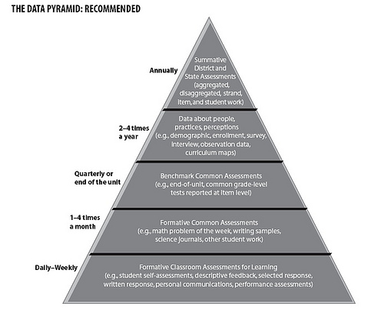

Each teacher is asked these:

1. What are points of pride or promise?
2. How might you use these points of pride or promise to spark improvement in other areas?
3. Which areas of the data pyramid could benefit from renewed focus and attention?

These questions will form the basis of follow-up conversations and planning:

1. What does the data seem to tell us?
2. What doesn’t the data tell us?
3. What else would we need to know?
4. What good news is there for us to celebrate?
5. What need for classroom or school improvement might arise from the data?
6. What kinds of data are being used when you receiving coaching after classroom visits?
7. What data could you consider using to inform your conversations?
8. How do parents and guardians feel about our school as a learning environment? How are we collecting this data?
9. What is your greatest needs in order to implement the instructional program effectively?

Autobiography in Five Short Chapters by Portia Nelson

I

I walk down the street.
There is a deep hole in the sidewalk
I fall in.
I am lost ... I am helpless.
It isn't my fault.
It takes me forever to find a way out.

II

I walk down the same street.
There is a deep hole in the sidewalk.
I pretend I don't see it.
I fall in again.
I can't believe I am in the same place
but, it isn't my fault.
It still takes a long time to get out.

III

I walk down the same street.
There is a deep hole in the sidewalk.
I see it is there.
I still fall in ... it's a habit.
my eyes are open
I know where I am.
It is my fault.
I get out immediately.

IV

I walk down the same street.
There is a deep hole in the sidewalk.
I walk around it.

V

I walk down another street.

Copyright (c) 1993, by Portia Nelson from the book There's A Hole in My Sidewalk.

